Project Reports

Introduction

1.1Overview

Vehicle management system is software which is

Helpful for bus operators,who wants to operate many bus trips in a day.vehicle management system is a windows application written for 32-bit windows operating systems which focused in the area of adding editing and deleting the passengers, stsff and the bus routes.

1.2 Purpose

* Vehicle management system is a software system.
* That serves to manage commercial fleets of vehicle, such as cars,vans or truks or even heavy equipment to ensure they utilized safely professionally.
* While making sure there well maintained and high performing.

2.Prablem Definition And Design Thinking

2. 1 Emphathy Map

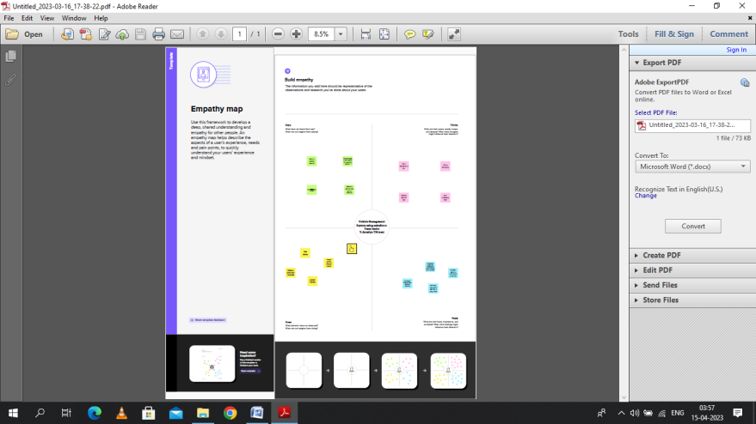

2.2 Ideation & Brainstroming Map

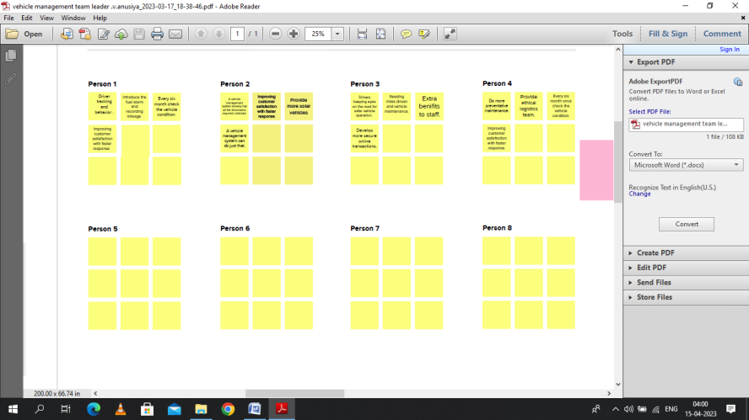

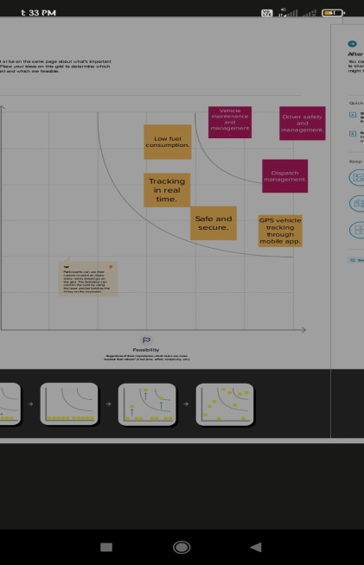 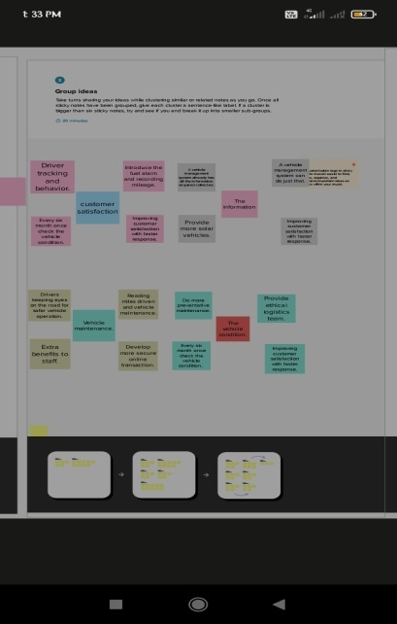

3. Result

3.1 Date Model

|  |  |
| --- | --- |
| Object | Filed In The Object |
| 1. Vehicle | |  |  |  | | --- | --- | --- | | S.No | Field Name | Date Type | | 1. | Customer Name | Text | | 2. | Customer Mobile No | Number | | 3. | Vehicle type  1.2wheeler  2.4wheeler | Picklist | | 4. | Vehicle Name | Text | | 5. | Vehicle No | Text | |
|  |  |
| 2.Driver | |  |  |  | | --- | --- | --- | | S.No | Field | Date Type | | 1. | Driver Name | Text | | 2. | Licence No | Text | | 3. | Mobile No | Number | | 4. | Fair Per Hour | Text | | 5. | Vehicle | Lookup(vehicle) | |

3.2 Activity &Screenshot

* Foremost we login into Salesfore platform.
* After that we generate objects.In our project we have two object.
* Vehicle
* Driver

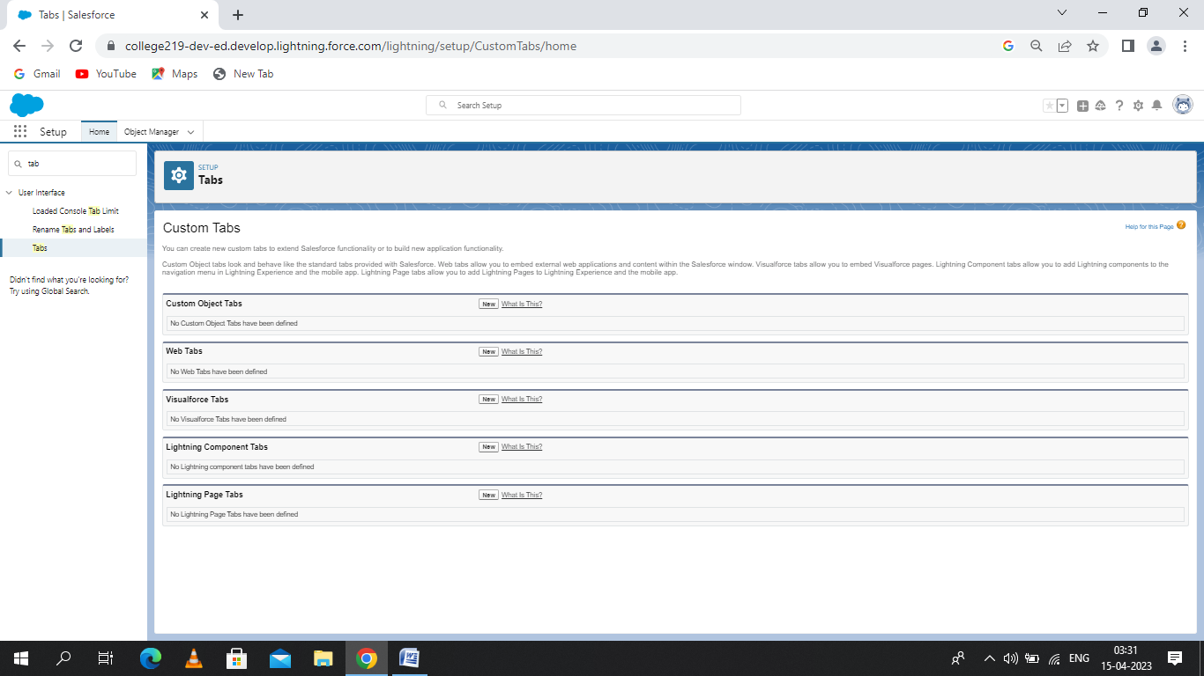

* And then we create “Field And Relationship”.

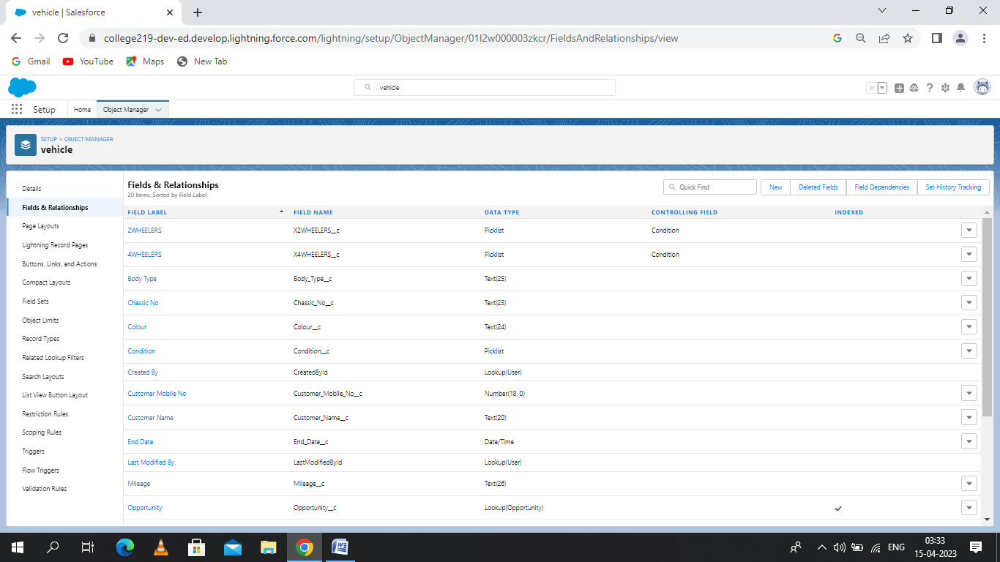

* On next step we generate “Lighting App” in milestone4.
* Afterwards in milestone 5 we create “profile”.

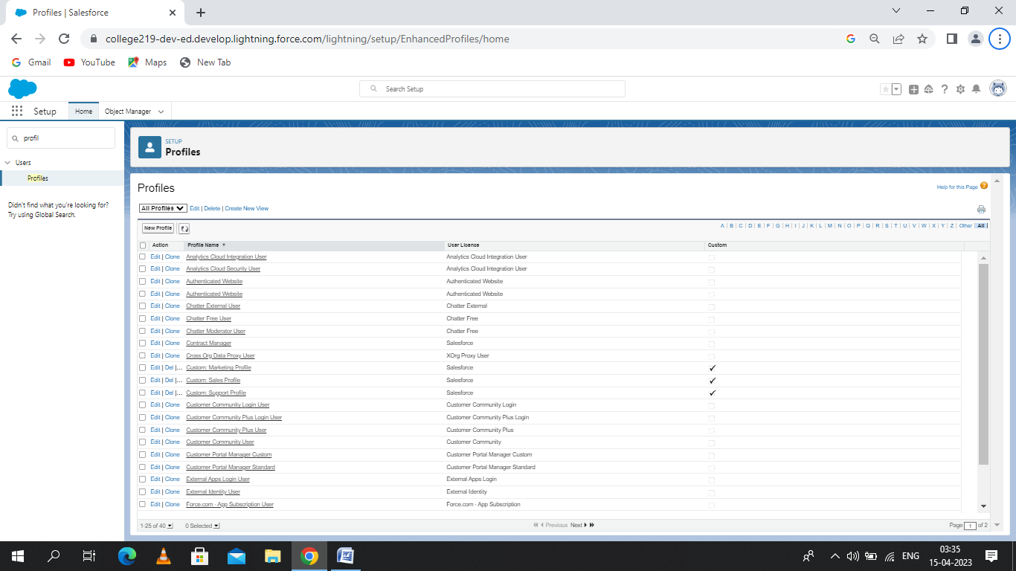

* After that me create “Users” on milestone6.

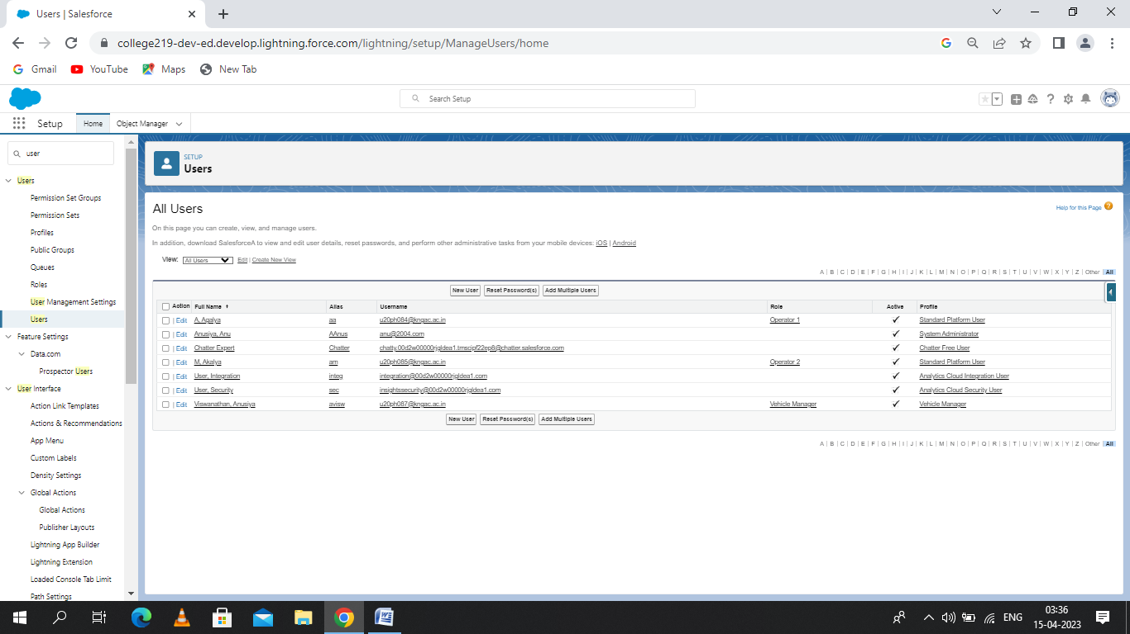

* New Account Report.

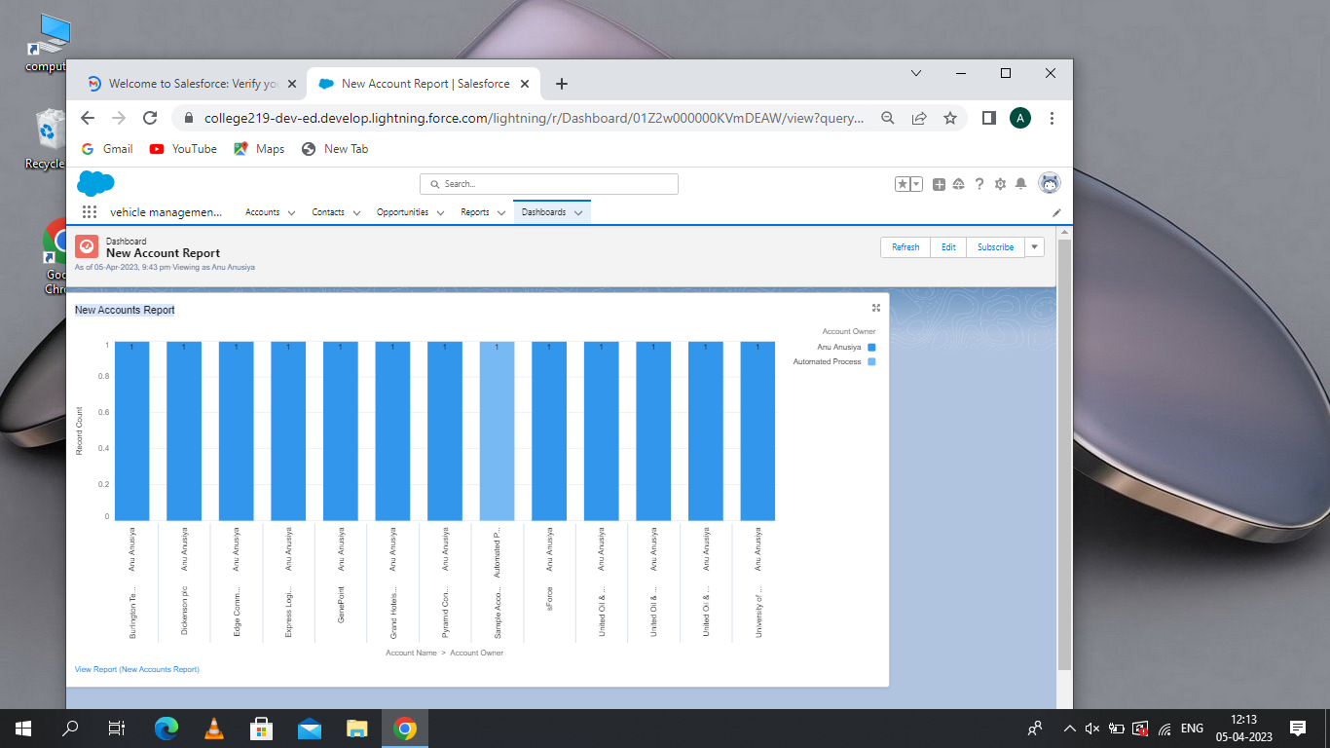

Trailhead Profile Public URL:

* Team Leader-https://trailblazer.me/id/aanusiya2
* V.Anusiya
* Team Member1-https://trailblazer.me/id /a2020batch12
* A.Aasha
* Team Member2-https://trailblazer.me/id/magalya
* M.Agalya
* Team Member3-https://trailblazer.me/id/aakalya1
* A.Akalya

5.Advantages

* Trackers can help vehicle owners protect one of their largest assets from thieves.
* Real time tracking allows a stolen car to be located within minutes from a smartphone or laptop.
* Not many people are aware that some trackers can helpto reduce car accidents and increase the safety of the driver.
* A GPS tracker help you monitor the location of your fleet and your employees which helps and breaks and track their total milage and delivery times.
* Whilst buying the tracking device itself can be pretty expensive, you will save money in other aspects.

6.Disadvantages

* Many people consider tracking vehicle to be an invasion of privacy ,which could be an issue if you re planning to use the device for business purposes.
* For a good vehicle tracker with all the mod cons, you can expect to pay quite a lot of money.
* These are becoming increasingly popular amongst tech savvy thieves.